Ihr Ansprechpartner:
Dirk Rott, Leiter Marketing

30 March 2020 / DRO
Press release WA2001: Redundant incremental encoder WDGR
Images and text material are released for publication in the trade press (print and online).
Please send us a specimen copy after publication. Thank you very much for your efforts..
_____________________________________________________________________
It doesn't always have to be SIL
Redundant incremental encoder WDGR
Diverse - and yet perfectly coordinated
High performance levels, lower costs

Costly SIL-certified devices do not always have to be used to perform safety-related tasks. With the WDGR series, Wachendorff Automation is launching a family of redundant incremental encoders with diverse sensor technology (optical and magnetic). In combination with appropriate control systems or, for example, speed monitors, high performance levels can be achieved at low cost.
The robust design familiar from Wachendorff - with protection class up to IP67 - provides very high immunity to interference. The high bearing loads of up to 220 N radial and up to 120 N axial contribute to this.

Wachendorff uses two different measuring principles here - optical and magnetic.
Fail-safety is specifically increased by using different measuring principles and as few identical components as possible. Specifically, Wachendorff's redundant standard encoders provide diverse signals that are generated completely independently of one another, but can still be correlated with one another. Even the power supplies are available separately for each sensor unit.
The basic idea behind this procedure is that the different sensor platforms also react with different sensitivities or insensitivities to disturbances of any kind and therefore do not fail simultaneously, so that the following electronics can reliably detect a possible failure.

Further information:
https://www.wachendorff-automation.com/products/encoders-redundant-en/

Image material (Wachendorff Automation):
1) 2)
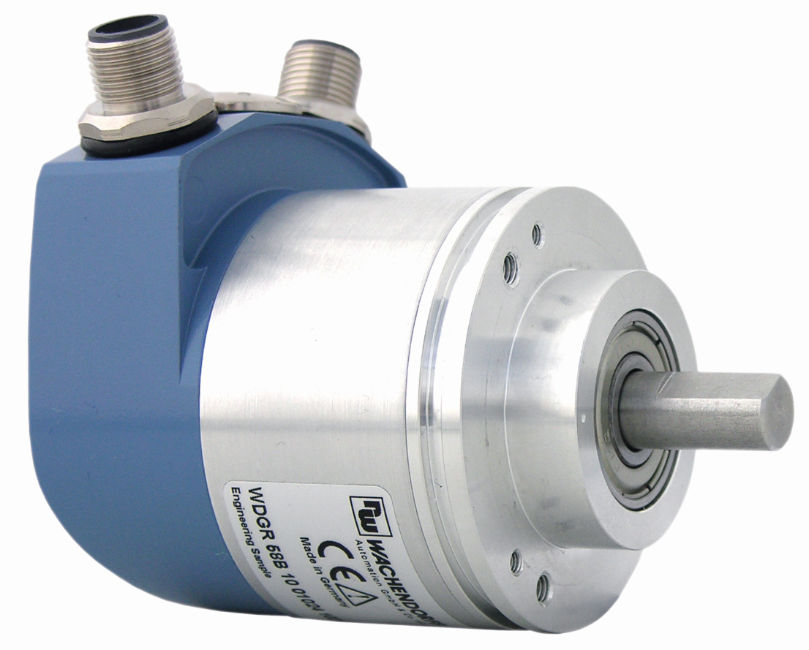 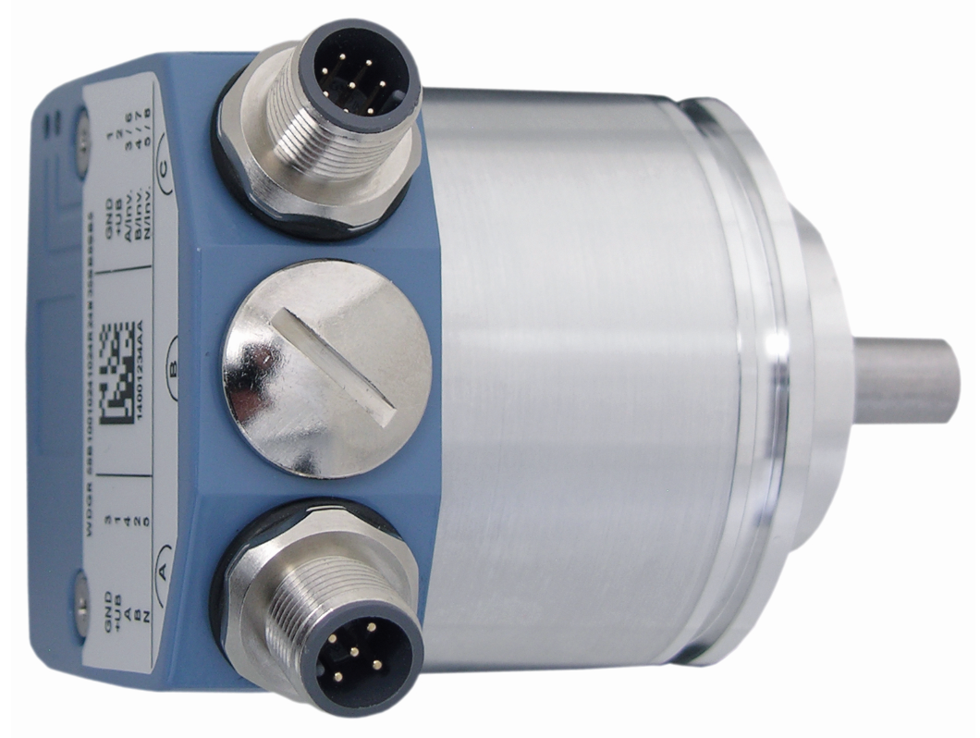
1) WA2001_Wachendorff_WDGR58B_30032020_1.jpg
2) WA2001_Wachendorff_WDGR58B_30032020_2.jpg

