27.08.2020 | Geisenheim | Sascha Isinger | VPM_2020_01_D

Press Release VPM_2001: KPI-Dashboard
Images and texts are released for publication in the trade press (print and online).
Please send us a specimen copy after publication. Many thanks for your efforts in advance.

KPI always in view
Live machine data visualization without software installation
Smart access to machine data

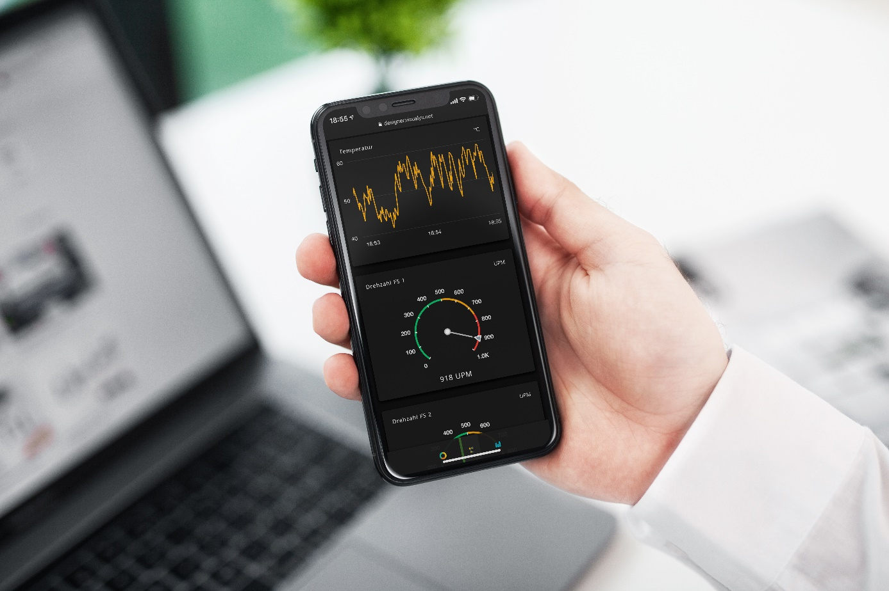
picture (VISUALYS): VPM_2001_D_KPI_Dashboard_mobil.jpg
The VISUALYS Machine KPI Dashboard can be used on any device and adapts perfectly to it. No installation of Apps & Co is required. Users of HMS Ewon Flexy Routers can use this Machine KPI Dashboard at any time and without hardware replacement.
This means that every user can call up the current live status and live performance of their machines within seconds, from any location worldwide.

More and More Smartphones and tablets find their way into the operation of machines and systems. In the B2C sector, users are used to performing various actions quickly and easily using mobile devices. Clearly designed and intuitively operated apps are crucial for acceptance and success. VISUALYS has taken care in the development of the Machine KPI Dashboard that these aspects are taken into account and that machine data is presented in a modern and appealing way on almost any device.
In addition, the VISUALYS solution offers local data visualization. This means that no data is transferred to the cloud or to external applications.
Any authorized user can access the dashboard of the machine via a secure access.

VPN router Ewon Flexy - the base that powers the KPI dashboard
The Ewon Flexy router series is the basis for this solution, which was developed from scratch. In the VISUALYS KPI dashboard there is no limit to the machine data to be displayed. The user defines this himself without any restrictions.
Via the communication protocols already integrated in the Ewon Flexy hardware, including MPI, Profibus, Modbus TCP, Profinet, data can be read and visualized directly from almost any control system.

Dashboard Designer - create optimal results from scratch
When developing the Machine KPI Dashboard, one of the most important aspects was that every user must be able to create his or her own specific dashboard within a very short time - without special training, without programming know-how, without experience.
The result is the VISUALYS Dashboard Designer.
The Dashboard Designer is the tool that can be used by any person, at any time.
There is no installation, no login, no registration of email addresses required.
The Dashboard Designer is freely available for testing on the VISUALYS website.
Once the dashboard has been designed by the user, it is compiled, linked to the serial number of the Ewon hardware and handed over to the customer.
If desired, the VISUALYS team can also remotely play the dashboard.

More information about the dashboard and designer: www.visualys.net
More information about the Ewon routers: www.wachendorff-prozesstechnik.de/ewon

About VISUALYS

VISUALYS GmbH is the corporate start-up of the Wachendorff Group and focuses on the development, integration and consulting of software around industry 4.0, SmartData and IIoT for the machine and plant manufacturer, as well as the operator.

VISUALYS GmbH is located in the beautiful Rheingau region, near Frankfurt and Wiesbaden.

For over 40 years the Wachendorff Group has gained experience in the field of industrial automation technology. With Wachendorff Prozesstechnik GmbH & Co KG, as one of the leading providers of industrial remote maintenance solutions, operating devices & panel PCs and gateways, VISUALYS quickly recognized that users are placing ever-increasing demands on data visualization and analysis. Based on this, VISUALYS exclusively deals with data analysis and visualization of machine data using the latest web technologies.

VISUALYS offers the user the right visualization and analysis concept from the multitude of available solutions, based on our years of experience.
The offer currently includes a smart KPI Dashboard for machine data visualization on Smartphone & Tablet, as well as a IIOT platform developed for the industry for central machine data acquisition and processing.

www.visualys.net

