Contact person for editorial offices:
Dirk Rott, Head of Marketing

August 1st, 2019

Press release WA1905: Torque support

Images and text are approved for publication in the press (print and online). Please send us a specimen copy after publication. Thank you for your efforts in advance.
________________________________________________________________________

New torque support WDGDS10020 ... compensate tolerances

The torque support WDGDS10020 compensates tolerances such as radial runout due to backlash or the drive shaft, as well as axial movements of the drive shaft when mounting hollow and end hollow shaft encoders.
The support consists of two maintenance-free rod ends, a maintenance-free threaded rod and is easy to install.
All you need is the appropriate screws to attach the torque arm to your machine. Everything else for mounting on the encoder is already included in the scope of delivery.

More information:
https://www.wachendorff-automation.com/encoder-torque-support-wdgds10020/

Image (Wachendorff Automation):
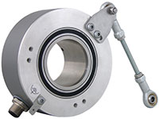
WA1905_Wachendorff_torque_suppor_encoder.jpg

