Intelligent encoder configurator with instant recall
Encoder configurator supplies a configured data sheet
Makes configuration fun!
With its configurator for incremental and absolute rotary encoders, Wachendorff Automation is able to offer design engineers and developers genuine added value compared with conventional configurators of the same class.
The Wachendorff tool is intelligent, and most importantly, can recall previous data. The programming holds a complete store of the combination of all the technical features and is capable of combining them (over 1.5 million possibilities), using an intelligent logic to manage them.
This intelligence and recall capability rules out any errors during the configuration process.
Any devices that may be considered are identified after just a few entries. Several other configurators are also able to offer this feature; the highlight of the Wachendorff configurator lies in generating a data sheet that is individually tailored to a configured rotary encoder.
Clicking a product type transfers selection criteria chosen in advance during preselection to the ‘product level’ and therefore ‘remembers’ them. The product page is developed individually for the user based on this just-in-time data, offering them the possibility to continue configuring and/or generate their individual data sheet at any time. This function is unique so far and extremely helpful!
Explanatory fields also offer effective electrical and mechanical information, enabling Wachendorff to offer the user the ability to put together their specific rotary encoder based on their actual requests and requirements. The user benefits from the ‘unique’ documentation, as for rotary encoders in particular there are very many interdependent factors in electrics and mechanics.

Exact rotary encoder types can be defined only with the help of expert knowledge. The data sheet ‘configured’ by Wachendorff can be saved as a PDF document or printed out.
One further interesting feature is that the particular status of the configuration can be documented in a PDF document at any time. This is helpful, for example, if the user wants advice about a definition from colleagues or technical support at Wachendorff Automation.
The configurator is available as a new feature on Wachendorff Automation’s website and in four different languages (German, English, French and Spanish).
More information at: http://www.wachendorff-automation.com/encoder-configurator.html

Photographic material (Wachendorff Automation):
Wachendorff_PI_WA1501_EncoderConfigurator_English_Print_12022015.jpg

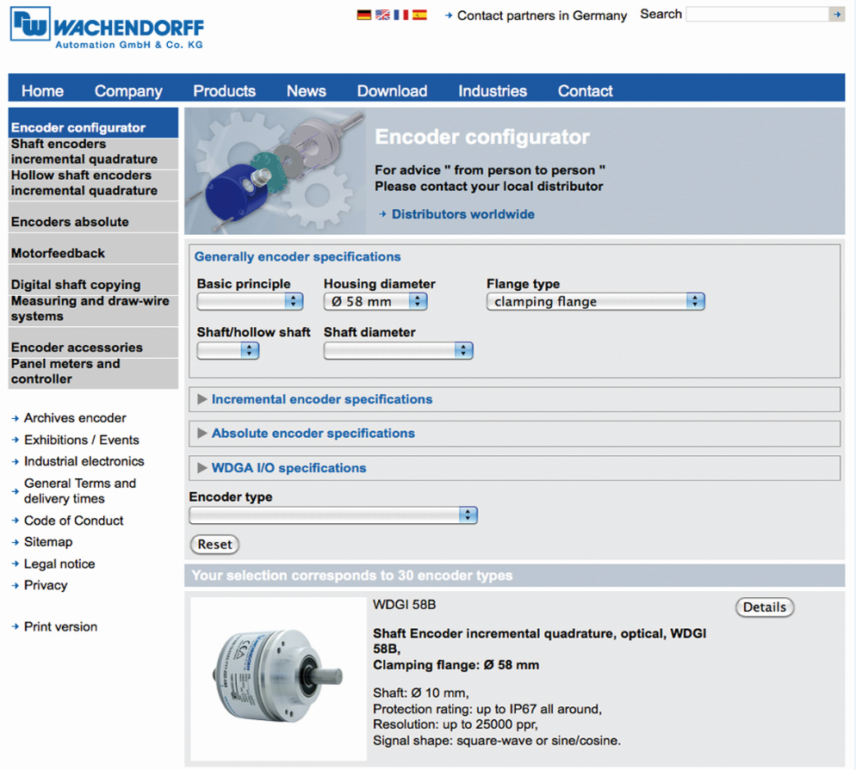

Caption:
The highlight of Wachendorff’s configurator is the ability to generate a data sheet that is individually tailored to the configured rotary encoder.

