Editorial team contact partner:
Dirk Rott, Head of Marketing
Hall A5, Stand 339
CiA stand

11th February 2016
Press Release WA1602: Automotive robust encoders
Images and text are approved for publication in the specialist press (print and online). Please send us a specimen copy after publication. Thank you for your efforts in advance.

Automotive robust encoders
Proven resistance to environmental influences
Many applications, numerous solutions ... always smart and automotive robust
Wachendorff Automation develops and manufactures industrial and automotive robust rotary encoders (incremental and absolute) and systems in Germany. Type tests accompanying the development process ensure that the encoders can be utilised reliably and durably in many sectors and mobile work machines, even in the harshest environmental conditions.
The specific strength of Wachendorff Automation is its absolute customer orientation and associated adaptation development to deliver truly optimal solutions. More than 1,500 customer/application-specific solutions are already being used successfully in series throughout the world. At BAUMA 2016, Wachendorff presented encoders and solutions for determining angles, distances, speeds, lengths and positions. The emphasis is on sensors with the CANopen, SAE J1939 and RS485 protocols. Wachendorff encoders are particularly compact and light. This saves you valuable space and weight. Application-specific protection classes, a very broad temperature range, high vibration and shock resistance, precise resolution and accuracy, high bearing loads and extreme immunity to magnetic influences guarantee durability and maximum service life. The outstanding Wachendorff Automation warranty period of five years highlights this.
BAUMA 2016, Hall A5, Stand 339, CiA stand
Wachendorff Automation GmbH & Co. KG, www.wachendorff-automation.com
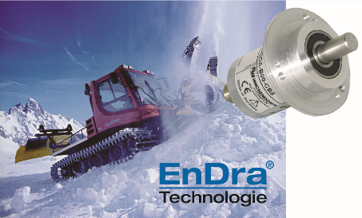
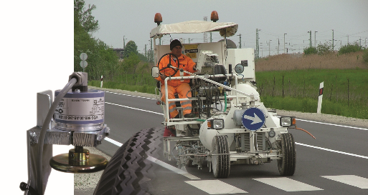
Images (Wachendorff):
WA1602_PI_BAUMA_Drehgeber_11022016_Strassenmarkierer.jpg
WA1602_ PI_BAUMA_Drehgeber_11022016_Pistenbully

